QA, Module configuration

**Brands**

1. Unable to save new brand, clicking on Save doesn’t do anything:

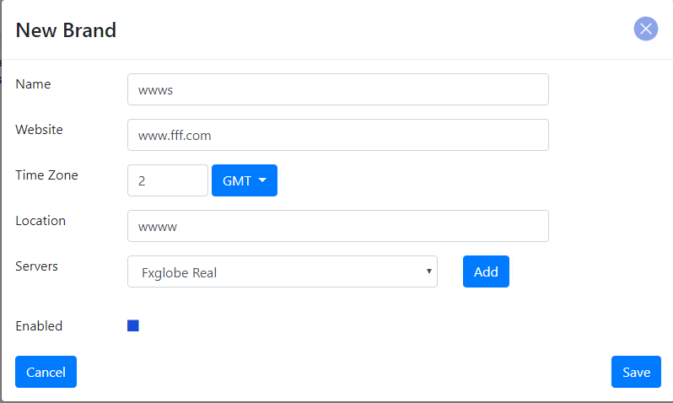

1. Unable to update server on a brand after it was created.
2. Please change the link name from: “Filtered Branches” to: “Associated branches”:

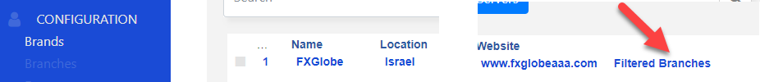

1. Search functionality doesn’t work:

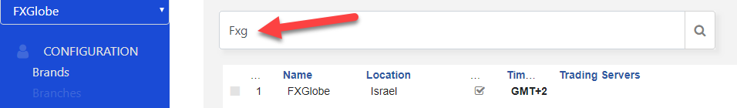

1. When adding new Brands it should show on the dropdown list of brands, and it doesn’t:

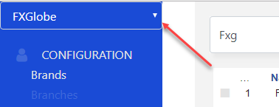

1. When a Brand is disabled please push it to the end of the list.
2. Search functionality seems not working:

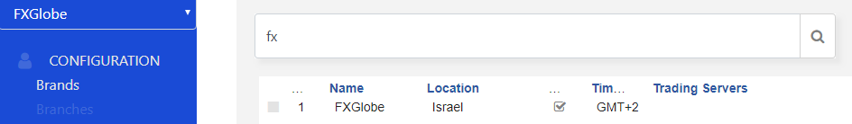

**Branch**

1. Table loads very slow sometimes. Can’t say when exactly, but if you encounter this please try and understand why.
2. When trying to edit a branch (seems like when only changing parent branch) the following error occur:

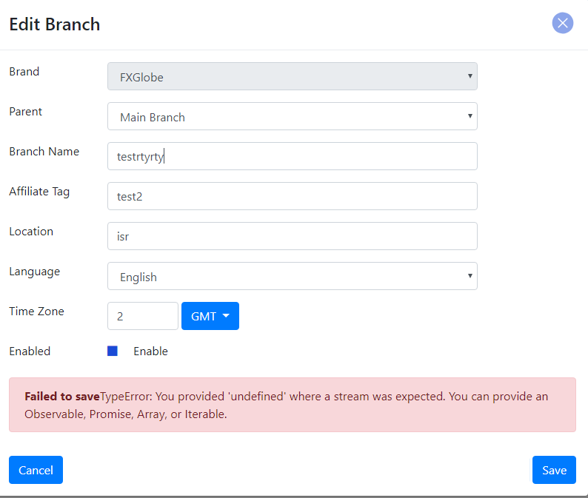

1. If not refreshed and starting a new branch, the error message still appears:

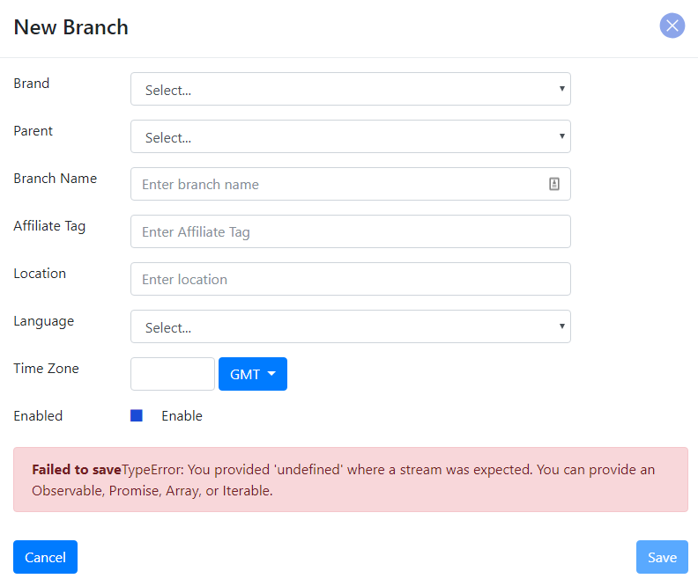

1. Please change the wordings from “filtered departments” to “Associated departments”:

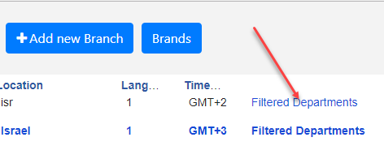

1. When saving new branch, the parent branch is not saved and it leaves it empty.
2. When creating branches, it should show on the parent branches the list of already created branches, right now because it doesn’t save the parent branch, on the dropdown you see only Main Branch and one test branch:

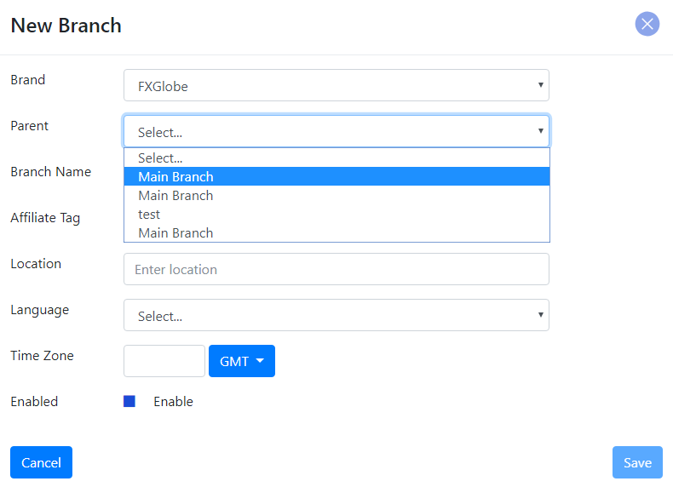

1. Sometimes the Parent Branch whole field is disappeared when editing a Branch:

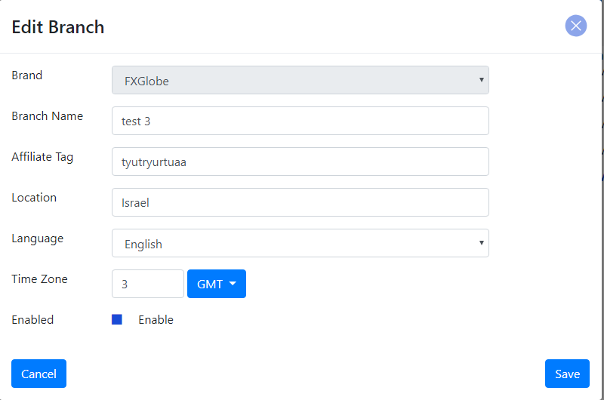

1. When a branch is disabled by the user please push him to the end of the list.

**Departments**

1. On the table 3 parameters doesn’t show a. Language b. Parent department c. Brand:

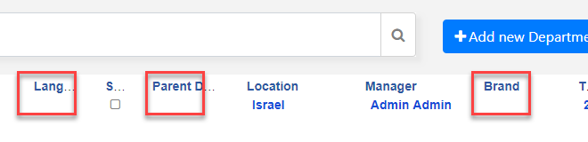

1. Language doesn’t save when editing a department (dept) :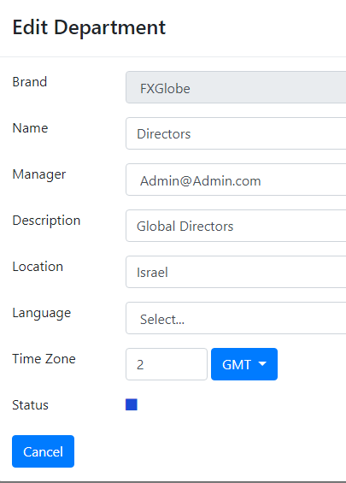
2. When disabling a dept, please push it to the end of the list.
3. When clicking on the dropdown list of the manager please show list of users by their name and not by email.
4. When creating a new department the default status is disabled, please change it to enabled:

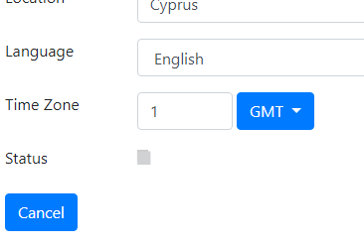

1. When adding new department, and clicking save it deletes all the fields I entered and doesn’t save it.
2. Missing Hierarchy, when creating departments with parent departments it creates a hierarchy tree, we wanted to easily show it in a simple diagram as per specs: 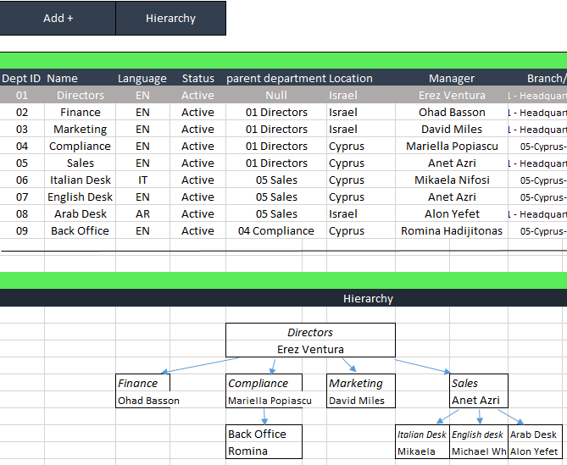

As you can see in the excel I have created this diagram just by knowing who is the parent department.

1. In the Hierarchy diagram it will show only the dept name and its manager, but when clicked on a box I want to have a full list of employees under this department.
2. On the table status always show as disabled although it is enabled:

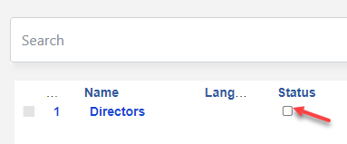

**Users**

1. When a user is disabled please push him to the end of the list.
2. When editing a user on the general tab, sometimes you can’t replace the image, button doesn’t change to “upload.
3. Please replace the entire image upload, please put a fixed image width and height and add a button to delete an image VS only replacing it: 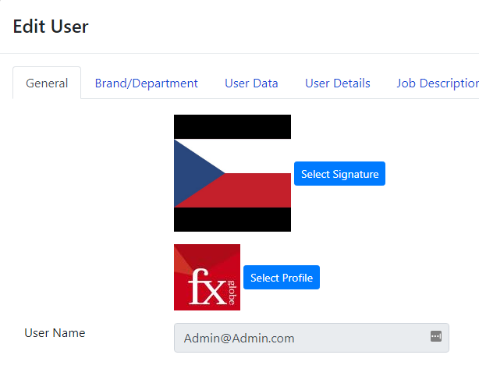
4. When editing a user it is necessary to add him to multiple departments and brands (not branches), it is impossible to add him to a new dept only Brands although wasn’t checked as the adding brand functionality doesn’t work now: 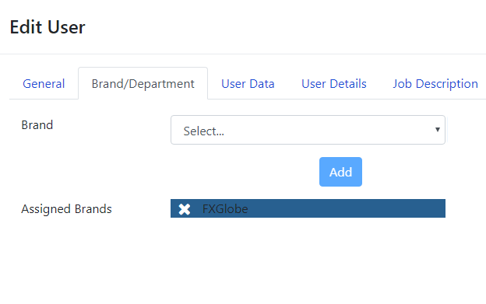
5. Mobile field validation doesn’t exist, we need country code area cose and the number, this concerns also to the SMS system sends, if it is not validated SMS’s will not be sent.
6. Password is not editable field, we need to be able to change a password:
7. Member since is a functionality that adds a user creation date, doesn’t work: 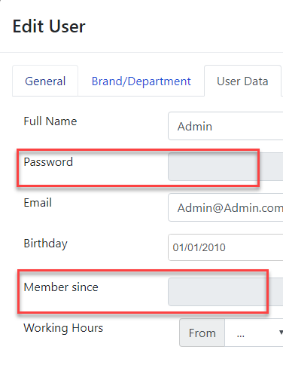
8. Working hours is missing the time zone that relates to it, this will be needed in the future for modules that needs to know users time zone and working hours:

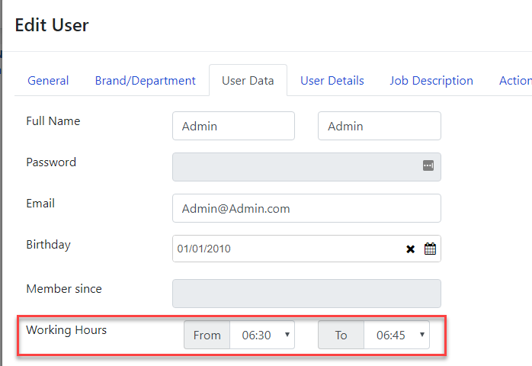

1. Multiple selection of dept per user doesn’t exist.
2. When creating new user, it shows the uploaded images as the previous one: 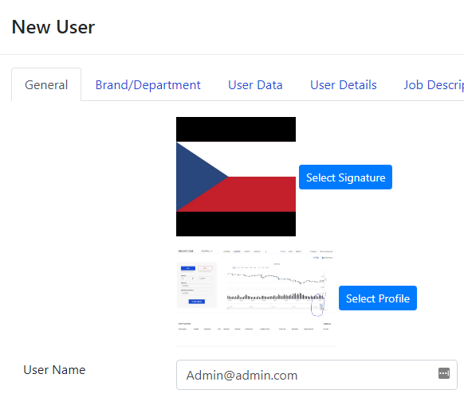
3. System allows you to choose the same Brand several times when clicking “Add”, please allow only one to one selection: 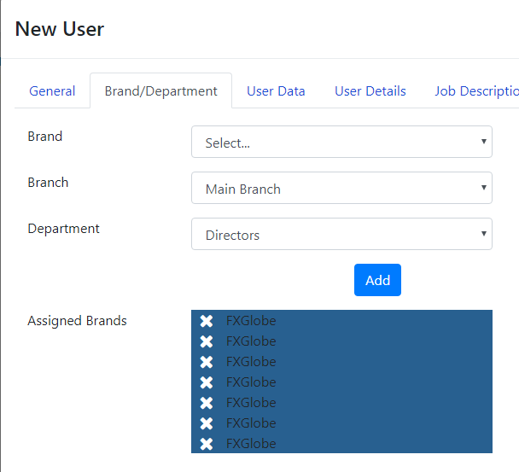
4. When creating new user it is disabled by default, please put it on enabled by default:

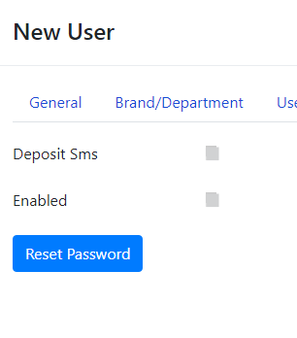

1. Add new user doesn’t work, Even when I seem to fill all information on all tabs the Save button is not active, therefore can’t create users. We need to have a tooltip above the save button to explain what is still missing.
2. Password complexity, what is it? Doesn’t have an explanation, it allows me to save a password with only 2 letters
3. When Cloning a user, the default Brand, Branch department works wrongly, the first stage it shows: 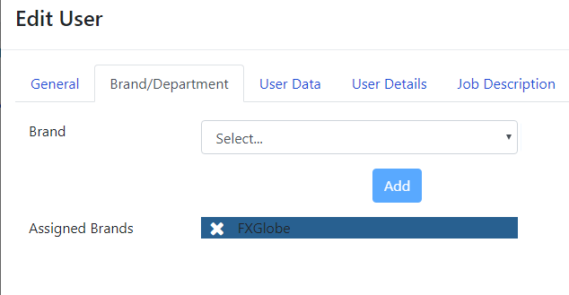

Since we don’t have more than 1 brand it doesn’t allow me to chose a branch and a department, only when I delete the Brand I get this when re-chosing the brand: 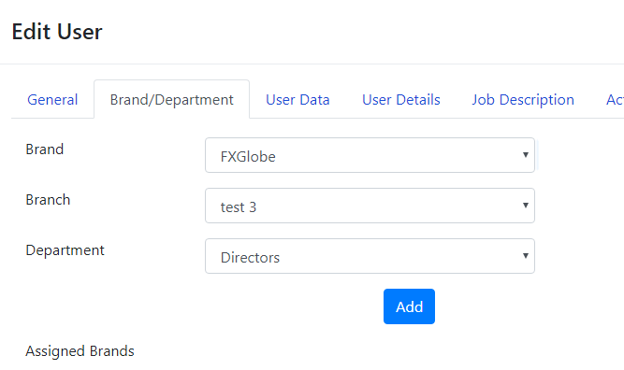

Again no multiple selection of dept, perhaps it is because we can’t create new dept currently because of the bug.